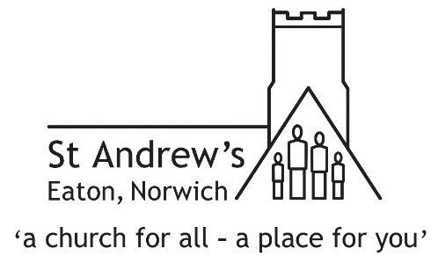
Climate and Environmental Emergency Recognition
November 2021

On the basis that:
- The world is facing a severe crisis of climate change and environmental degradation, that is already having a major impact on sea levels and weather patterns around the world.
- The main cause of this crisis is human activity, and if radical action is not taken urgently, the changes will become far worse and irreversible.
- The poorest people around the world contribute the least to climate change, and yet are already experiencing the devastating impact.
- The crisis indicates a failure of human beings to follow God’s mandate to care for the world and all its biodiversity, to seek justice among its peoples and to love our neighbour.

Therefore we, St Andrew’s Church, Eaton, commit to:
- Examining our life as a church and seeking to live more faithfully to God as carers of his creation, under the guidance of the Church Council’s Eco Church Team.
- Assessing where possible each decision in light of its environmental impact.
- Supporting the whole church community, and the wider community of Eaton, in making necessary lifestyle changes, through initiatives such as the 2022 Spring Eco Fair.
- Increasing the biodiversity of our churchyard and burial ground and encouraging greater enjoyment of them by the local community.
- Working towards applying for a Silver Eco Church Award.

