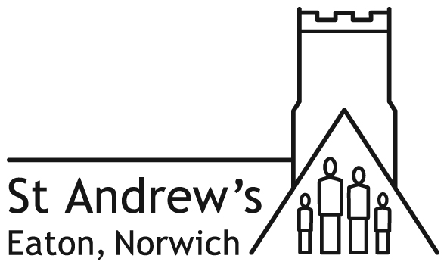

ST ANDREW’S CHURCH AND HALL HIRING CHARGES

 | Regular bookings  (once a month or more)  HALL  Per hour | One off (occasional) bookings  HALL  Per hour | One off (occasional) bookings  CHURCH  Per hour
Summer | £15.00 | £20.00 | £30.00
Winter | £18.00 | £25.00 | £35.00

Rental periods for the hall and church are in half hour blocks and the minimum period of rental is one hour. The maximum time charge per day is £150 in summer and £180 in winter.

Winter bookings run from 1 October to 30 April - those that normally require heating.

Please note that, when you calculate the hire charge for the hall or church, the length of your booking must be from the time you arrive to the time you leave: this must include time for setting up and clearing up.

A Breakages Deposit of £50.00 is required for all one off / occasional bookings. The deposit will be returned after the hire, with a reduction for any extra costs incurred in cleaning or tidying and in making good any loss or repairs.

Charges include cleaning, tidying, opening, and locking up and for additional heating/lighting in winter, but facilities must always be left in a clean and tidy condition by the hirer. All rubbish must be taken away – not put in the Hall wheelie bins.

Payment for one off / occasional bookings must be made at the time of booking. Regular bookings will be paid monthly or termly in advance. No bookings will be accepted more than one term ahead.

Regular bookings are defined as ones that are not normally more than a calendar month apart, for example, fortnightly in term-time or ten or more bookings a year would be regular bookings.

Start and finish times The church and hall are available for set-up from 8.30am for a 9.00am start. Facilities are not normally available after 11.00pm except by special arrangement.

Charge for use of the church organ or piano is £20 per day, excluding weddings and funerals.

Church hiring will require the presence of a site manager at an additional cost of £40, if there is church furniture to be moved in setting up and clearing up.

Refunds for cancelled bookings. A full refund will be paid if four weeks’ notice is given, a half refund for two weeks’ notice.

Please see separate charges relating to fees for Banns, Weddings and Funerals.

See booking form for terms and conditions of hire. Charges from 28/10/2019

